Filename: ./components/TaskInput.js

Code:

import React, { useState } from 'react';

function TaskInput({ onAdd }) {

const [input, setInput] = useState('');

const handleAdd = () => {

if (input.trim()) {

onAdd(input.trim());

setInput('');

}

};

return (

<div className="task-input">

<input

type="text"

placeholder="Enter a new task..."

value={input}

onChange={(e) => setInput(e.target.value)}

/>

<button onClick={handleAdd}>Add Task</button>

</div>

);

}

export default TaskInput;

Filename: ./components/TaskItem.js

Code:

import React from 'react';

function TaskItem({ task, onToggle, onDelete }) {

return (

<li className={`task-item ${task.completed ? 'completed' : ''}`}>

<input

type="checkbox"

checked={task.completed}

onChange={() => onToggle(task.id)}

/>

<span>{task.text}</span>

<button className="delete-btn" onClick={() => onDelete(task.id)}>🗑️</button>

</li>

);

}

export default TaskItem;

Filename: ./components/TaskList.js

Code:

import React from 'react';

import TaskItem from './TaskItem';

function TaskList({ tasks, onToggle, onDelete }) {

return (

<ul className="task-list">

{tasks.map(task => (

<TaskItem

key={task.id}

task={task}

onToggle={onToggle}

onDelete={onDelete}

/>

))}

</ul>

);

}

export default TaskList;

Filename: App.css

Code:

body {

font-family: 'Segoe UI', sans-serif;

background-color: #f0f2f5;

margin: 0;

padding: 0;

}

.app-container {

max-width: 500px;

margin: 40px auto;

padding: 20px;

background-color: #fff;

box-shadow: 0 8px 16px rgba(0,0,0,0.1);

border-radius: 12px;

}

h1 {

text-align: center;

color: #333;

}

.task-input {

display: flex;

gap: 10px;

margin-bottom: 20px;

}

.task-input input {

flex-grow: 1;

padding: 10px;

border: 2px solid #ccc;

border-radius: 8px;

font-size: 16px;

}

.task-input button {

padding: 10px 16px;

border: none;

background-color: #007bff;

color: white;

border-radius: 8px;

cursor: pointer;

}

.task-list {

list-style: none;

padding: 0;

}

.task-item {

background: #f9f9f9;

padding: 12px;

margin-bottom: 10px;

border-radius: 8px;

display: flex;

justify-content: space-between;

align-items: center;

transition: 0.3s;

}

.task-item span {

cursor: pointer;

flex-grow: 1;

}

.task-item.completed span {

text-decoration: line-through;

color: gray;

}

.task-item input[type="checkbox"] {

margin-right: 10px;

transform: scale(1.2);

}

.delete-btn {

background: none;

border: none;

font-size: 18px;

cursor: pointer;

}

Filename: App.js

Code:

import React, { useState } from 'react';

import TaskInput from './components/TaskInput';

import TaskList from './components/TaskList';

import './App.css';

function App() {

const [tasks, setTasks] = useState([]);

const addTask = (text) => {

const newTask = { id: Date.now(), text, completed: false };

setTasks([...tasks, newTask]);

};

const toggleComplete = (id) => {

setTasks(tasks.map(task =>

task.id === id ? { ...task, completed: !task.completed } : task

));

};

const deleteTask = (id) => {

setTasks(tasks.filter(task => task.id !== id));

};

return (

<div className="app-container">

<h1>To-Do List Planner</h1>

<TaskInput onAdd={addTask} />

<TaskList tasks={tasks} onToggle={toggleComplete} onDelete={deleteTask} />

</div>

);

}

export default App;

Output: default

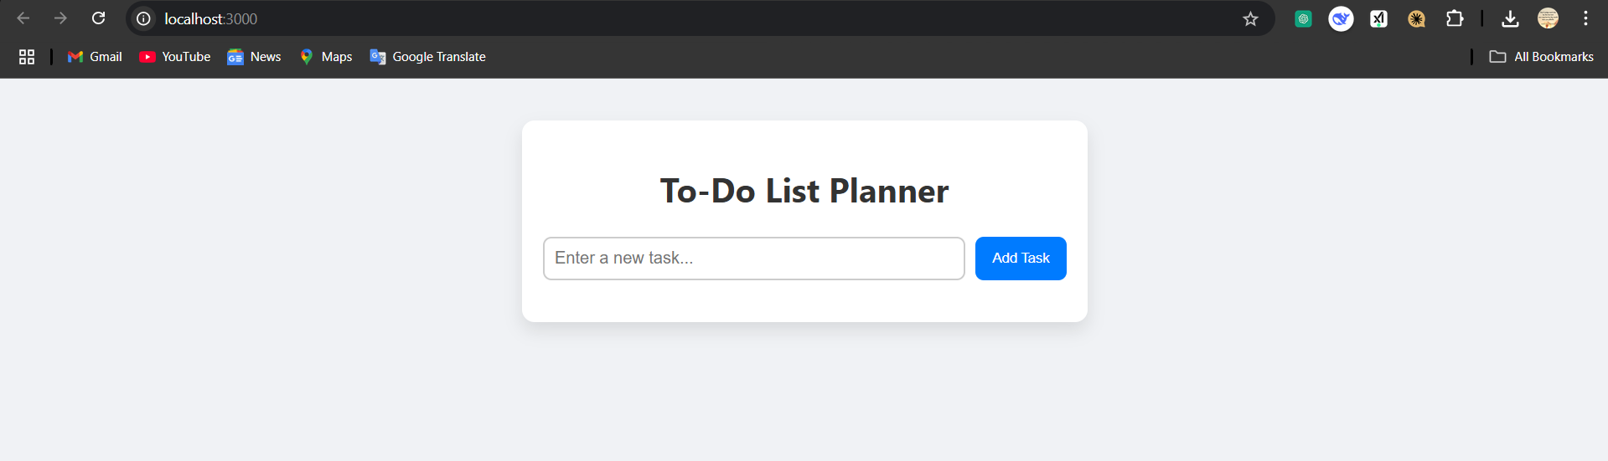

* Adding a task

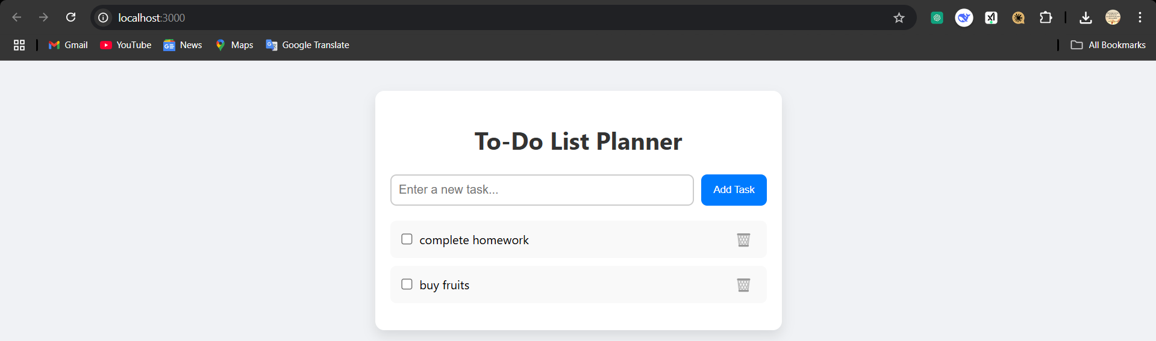

* Completed tasks

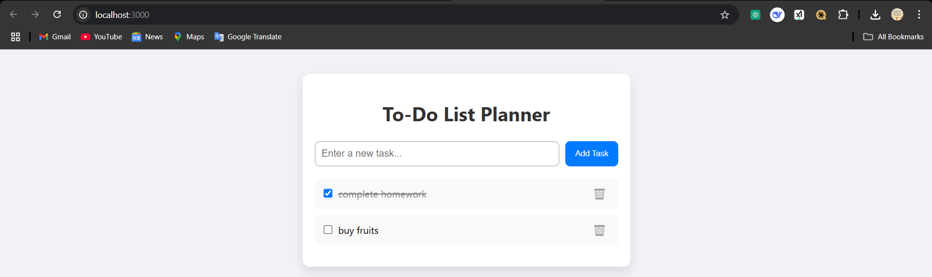

* Delete tasks

